7.1.5 Editors - 3D View - Header - Select Menu
Detailed Table of content 3
Select menu 9
Object Mode - Select menu 9
All 9
None 9
Inverse 9
Grouped 9
Linked 9
All by Type 10
Random 11
Mirror Selection 11
By Pattern 11
Active Camera 12
More/ Less 12
Edit Mode - Mesh Menu 13
All 13
None 13
Inverse 13
Linked 13
Linked Flat Faces 14
Linked Pick Select 14
Linked Pick Deselect 14
Similar 14
Random 15
Checker Deselect 15
Side of Active 16
Shortest Path 16
Sharp Edges 17
Loose Geometry 18
Interior Faces 18
Faces by Sides 18
Edge Loop 18
Edge Ring 19
Loop Inner-Region 19
Boundary Loop 19
Ungrouped Verts 19
More / Less 20
Curve Object - Edit Mode 20
All 20
None 20
Inverse 20
Linked 20
Linked Pick Select 21
Linked Pick Deselect 21
Similar 21
Random 22
Checker Deselect 22
De/Select First 22
De/Select Last 22
Next Active 22
Previous Active 23
More 23
Less 23
Surface Object - Edit Mode 23
All 23
None 23
Inverse 23
Linked 23
Similar 23
Random 24
Checker Deselect 24
Control Point Row 25
More 25
Less 25
Metaball Object - Edit Mode 25
All 25
None 25
Inverse 25
Similar 25
Random 26
Grease Pencil Object - Edit Mode, Sculpt Mode 26
All 26
None 26
Inverse 26
Lasso Select 26
Box Select 27
Circle Select 27
Linked 27
Alternated 27
Grouped 28
First 28
Last 28
More 28
Less 29
Armature Object - Edit Mode 29
All 29
None 29
Inverse 29
Similar 29
Mirror Selection 30
By Pattern 30
Armature Object - Pose Mode 31
All 31
None 31
Inverse 31
Grouped 31
Constraint Targets 32
By Pattern 32
Flip Active 32
Lattice Object - Edit Mode 33
All 33
None 33
Inverse 33
Mirror 33
Ungrouped Verts 34
More 34
Less 34
Particles - Particle Mode 34
All 34
None 34
Inverse 34
More 34
Less 34
Random 35

Detailed Table of content

Detailed table of content
Detailed Table of content 3
Select menu 9
Object Mode - Select menu 9
All 9
None 9
Inverse 9
Grouped 9
Last Operator Select Grouped 9
Extend 9
Type 9
Linked 9
Object Data 10
Material 10
Instanced Collection 10
Particle System 10
Library 10
Library (Object Data) 10
All by Type 10
Last Operator Select By Type 10
Extend 10
Type 11
Random 11
Last Operator Select Random 11
Percent 11
Random Seed 11
Action 11
Mirror Selection 11
Last Operator Select Mirror 11
Extend 11
By Pattern 11
Pattern 12
Case Sensitive 12
Extend 12
Last Operator Select Pattern 12
Active Camera 12
More/ Less 12
More 12
Less 12
Parent 12
Child 12
Parent extended 12
Child Extended 12
Edit Mode - Mesh Menu 13
All 13
None 13
Inverse 13
Linked 13
Last Operator Select Linked All 13
Delimit 13
Linked Flat Faces 14
Last Operator Select Linked Flat Faces 14
Linked Pick Select 14
Linked Pick Deselect 14
Last Operator Select Linked 14
Deselect 14
Delimit 14
Similar 14
Last Operator Select Similar 14
Type 14
Compare 14
Threshold 15
Random 15
Last Operator Select Random 15
Percent 15
Random Seed 15
Action 15
Checker Deselect 15
Last Operator Checker Deselect 15
Nth Element 15
Skip 15
Offset 15
Last Operator Select Mirror 16
Axis 16
Extend 16
Side of Active 16
Last Operator Side of Active 16
Axis mode 16
Axis Sign 16
Axis 16
Threshold 16
Shortest Path 16
Last Operator Select shortest path 16
Edge Tag 17
Face Stepping 17
Topology Distance 17
Fill Region 17
Nth Element 17
Skip 17
Offset 17
Sharp Edges 17
Last Operator Select Sharp Edges 17
Sharpness 17
Loose Geometry 18
Last Operator Select Loose Geometry 18
Extend 18
Interior Faces 18
Faces by Sides 18
Last Operator Select Faces by Side 18
Sharpness 18
Number of vertices 18
Type 18
Extend 18
Edge Loop 18
Last Operator Multi Select Loops 19
Ring 19
Edge Ring 19
Last Operator Multi Select Loops 19
Ring 19
Loop Inner-Region 19
Last Operator Select Loop Inner-Region 19
Select Bigger 19
Boundary Loop 19
Ungrouped Verts 19
Last Operator Select Ungrouped 19
Extend 19
More / Less 20
More 20
Less 20
Next Active 20
Previous Active 20
Curve Object - Edit Mode 20
All 20
None 20
Inverse 20
Linked 20
Last Operator Select Linked All 21
Delimit 21
Linked Pick Select 21
Linked Pick Deselect 21
Last Operator Select Linked 21
Deselect 21
Delimit 21
Similar 21
Last Operator Select Similar 21
Type 21
Compare 21
Threshold 21
Random 22
Last Operator Select Random 22
Percent 22
Random Seed 22
Action 22
Checker Deselect 22
Last Operator Checker Deselect 22
Nth Element 22
Skip 22
Offset 22
De/Select First 22
De/Select Last 22
Next Active 22
Previous Active 23
More 23
Less 23
Surface Object - Edit Mode 23
All 23
None 23
Inverse 23
Linked 23
Last Operator Select Linked All 23
Delimit 23
Similar 23
Last Operator Select Similar 24
Type 24
Compare 24
Threshold 24
Random 24
Last Operator Select Random 24
Percent 24
Random Seed 24
Action 24
Checker Deselect 24
Last Operator Checker Deselect 24
Nth Element 24
Skip 24
Offset 24
Control Point Row 25
More 25
Less 25
Metaball Object - Edit Mode 25
All 25
None 25
Inverse 25
Similar 25
Last Operator Select Similar 25
Type 25
Compare 25
Threshold 25
Random 26
Last Operator Select Random 26
Percent 26
Random Seed 26
Action 26
Grease Pencil Object - Edit Mode, Sculpt Mode 26
All 26
None 26
Inverse 26
Lasso Select 26
Box Select 27
Circle Select 27
Linked 27
Last Operator Select Linked All 27
Delimit 27
Alternated 27
Last Operator Alternated 28
Unselect Ends 28
Grouped 28
Last Operator Select Grouped 28
Type 28
First 28
Last Operator Select First 28
Selected Strokes only 28
Extend 28
Last 28
Last Operator Select Last 28
Selected Strokes only 28
Extend 28
More 28
Less 29
Armature Object - Edit Mode 29
All 29
None 29
Inverse 29
Similar 29
Last Operator Select Similar 29
Type 29
Compare 29
Threshold 29
Mirror Selection 30
Last Operator Select Mirror 30
Extend 30
By Pattern 30
Pattern 30
Case Sensitive 30
Extend 30
Last Operator Select Pattern 30
Parent 30
Child 31
Extend Parent 31
Extend Child 31
More 31
Less 31
Armature Object - Pose Mode 31
All 31
None 31
Inverse 31
Grouped 31
Constraint Targets 32
By Pattern 32
Pattern 32
Case Sensitive 32
Extend 32
Last Operator Select Pattern 32
Flip Active 32
Last Operator Flip Active/Selected Bone 32
Active Only 32
Extend 33
Parent 33
Child 33
Extend Parent 33
Extend Child 33
Lattice Object - Edit Mode 33
All 33
None 33
Inverse 33
Mirror 33
Last Operator Select Mirror 33
Axis 33
Extend 33
Ungrouped Verts 34
Last Operator Select Ungrouped 34
Extend 34
More 34
Less 34
Particles - Particle Mode 34
All 34
None 34
Inverse 34
More 34
Less 34
Random 35
Last Operator Select Random 35
Percent 35
Random Seed 35
Action 35
Type 35

Select menu

The Select menu provides you with all functionality around selecting. The content differs, dependant in which mode you are, and what object type you have selected. Some select functionality is very special for just one object type in one special mode. But not every mode has a select menu.

Object Mode - Select menu

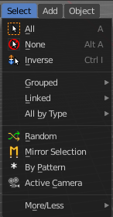
The select menu in Object mode is for all object types equal. It provides you with several selection methods.

All
Select everything.

None
Select nothing.

Inverse
Invert the current selection.

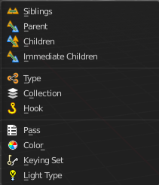
Grouped
Here you can select different types of objects within the group. It requires to have a group selected.
The menu items are pretty self explaining. So we won't go into detail here.

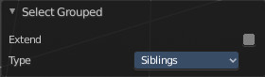
Last Operator Select Grouped

Extend
Extends existing selection instead of deselecting everything first.

Type
Type is a drop-down list where you can choose the Linked type again.

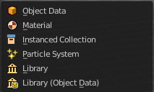
Linked
Linked is a menu where you can select different types.
Here you can select all objects that shares a common data-block with the active object. Select Linked uses the active object as a basis to select all others.

Object Data
Selects every object that is linked to the same Object Data.

Material
Selects every object that is linked to the same material data-block.

Instanced Collection
Selects every object that is linked to the instanced collection.

Particle System
Selects all objects that use the same Particle System.

Library
Selects all objects that are in the same Library.

Library (Object Data)
Selects all objects that are in the same Library and limited to object data.

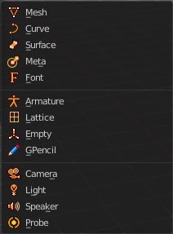
All by Type
Here you can select objects of a specific type.
The menu items are pretty self explaining. So we won't cover every single menu item here.

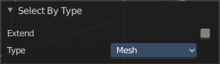
Last Operator Select By Type

Extend
With this option activated the selection does not clear before performing the selection operation, but extends. This means when you have a mesh object selected, and want to select all objects by type curve, then the mesh object is still selected. Without Extend just the curve objects are selected. The mesh object gets deselected.

Type
Type is a drop-down box where you can choose the object type to select again.

Random
Selects random objects.

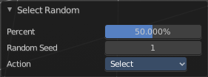
Last Operator Select Random

Percent
The Percentage of objects that should be selected randomly.

Random Seed
The Seed for the random number generator.

Action
Action is a drop-down box where you can choose if you want to select or to deselect random.

Mirror Selection
Select the mirrored parts of an object. For example for L.Sword it selects R.Sword.

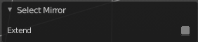
Last Operator Select Mirror

Extend
Extends existing selection instead of deselecting everything first.

By Pattern
Selects all objects whose name matches the entered string. For missing parts you need to add an asterix.
For example, you have four cubes in the scene. Cube, Cube.001, Cube.002 and mycube3. Then the term " Cube " will just select the first cube. While the term " Cube* " will select the first three. And " *cube* " will select all four.
Supported wild-cards:
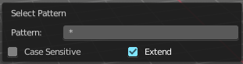
* matches everything
? matches any single character
[abc] matches characters in “abc”
[!abc] match any character not in “abc”
The tool operates immediately at entering the string.

Pattern
Here you can type in your string.

Case Sensitive
When ticked then the string comparison happens by taking upper and lower letters into account.

Extend
Extends existing selection instead of deselecting everything first.

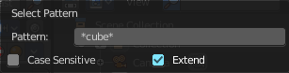
Last Operator Select Pattern
The Last Operator Select Pattern contains the same menu items than the pop-up. So see above. Also, it does not appear in the 3D view. But when you call it from the edit menu or with hotkey.

Active Camera
Selects the active camera.

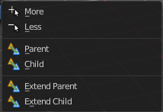
More/ Less

More
More requires to have a parent or child relationship. It expands the selection.

Less
Less requires to have a parent or child relationship. It reduces the selection.

Parent
Parent requires to have a parent or child relationship. It selects the parent object of the currently selected object(s).

Child
Child requires to have a parent or child relationship. It selects the child object(s) of the currently selected object(s).

Parent extended
Parent extended requires to have a parent or child relationship. It selects the parent object of the currently selected object(s). But keeps the active object in the selection, even when it's not currently selected.

Child Extended
Child Extended requires to have a parent or child relationship. It selects the child object(s) of the currently selected object(s). But keeps the active object in the selection, even when it's not currently selected.

Edit Mode - Mesh Menu

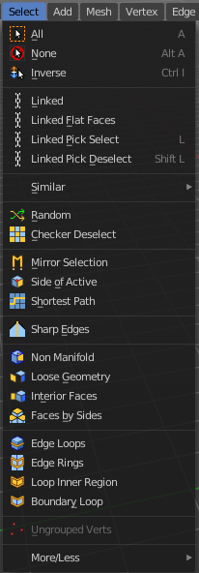
The select menu for a mesh object in Edit mode.

A few tools here acts different, dependant in which mesh select mode you are. For example, when you are in mesh select method vertices, then the Random operator picks random vertices.

So you might want to check the mesh select mode when something does not work in an expected way.

All
Select everything.

None
Select nothing.

Inverse
Invert the current selection.

Linked
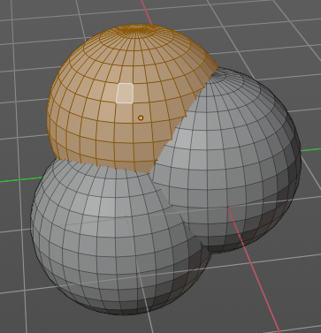
Select the geometry that is directly linked with the current geometry. You can for example have a mesh with several closed submeshes. Those submeshes are not linked together, but are part of the object.

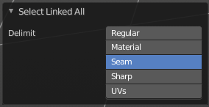
Last Operator Select Linked All

Delimit
Here you can add a limit to the selection. For example, just select up to the next seam.

Linked Flat Faces
Select the geometry that is coplanar to the current selection. It works also in other selection modes, but you need to have face geometry selected.

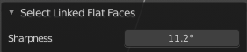
Last Operator Select Linked Flat Faces
Here you can adjust the angle up to which a face counts as coplanar.

Linked Pick Select
Same as with Linked. But works with what is under the mouse cursor.

Linked Pick Deselect
Same as with Linked. But works with what is under the mouse cursor. And deselects the selection.

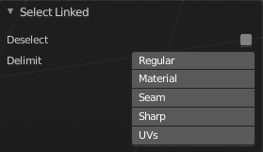
Last Operator Select Linked

Deselect
Select or deselect.

Delimit
Here you can add a limit to the selection. For example, just select up to the next seam.

Similar
Here you can select geometry based on how similar certain properties are to it. The methods changes, dependant in which mesh selection mode you are. There is a pitfall with having more than one mesh selection method selected. Then you just get the face regions type presented. Vertices, Edges, Faces, more than one ...
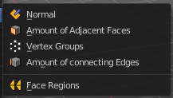
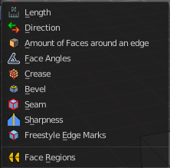
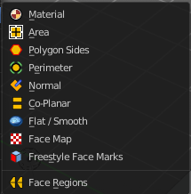
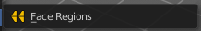

Last Operator Select Similar

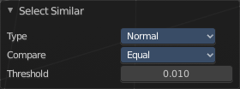
Type
Here you can choose the select similar method again.

Compare
Compare with method less, greater or equal.

Threshold
Here you can adjust the threshold value after which the element counts as similar.

Random
Selects a random group of vertices, edges, or faces, dependant of the mesh selection method.

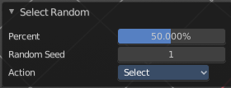
Last Operator Select Random

Percent
How much percent will be random selected.

Random Seed
The random seed value.

Action
Select or deselect.

Checker Deselect
Deselect alternating faces, edges or vertices to create a checker like pattern. The result is dependant of the mesh selection method.

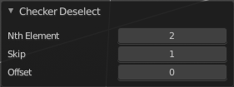
Last Operator Checker Deselect

Nth Element
Here you can define how much elements gets unchecked. With 2 you have a checker board pattern. Every second element gets deselected.

Skip
Skip elements before the checker algorithm deselects again.

Offset
Here you can offset the deselected elements.

Mirror selection
Requires to have a symmetrical mesh. Selects the mirrored mesh parts from a selection.

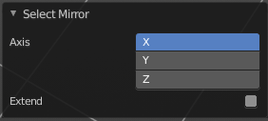
Last Operator Select Mirror

Axis
The world axis to mirror at.

Extend
Keep the current selection. Without extend the current selection gets deselected.

Side of Active
Selects all mesh data in direction of a single axis, starting from the current selection.

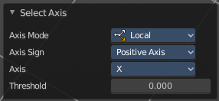
Last Operator Side of Active

Axis mode
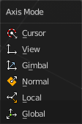
The axis orientation to work with.

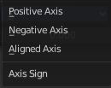
Axis Sign
In which direction to work form the current selection.

Axis
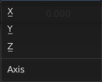
The axis to work with.

Threshold
Here you can define a threshold to extend the selection.

Shortest Path
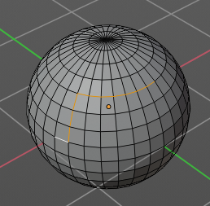
Select the shortest edge path between two selected mesh elements. This can be vertices, edges or faces. A start and a end point must be selected.

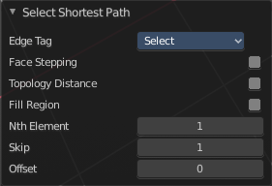
Last Operator Select shortest path

Edge Tag
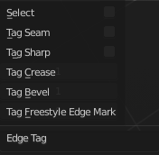
With Select shortest path you can not only select the shortest path, but also already modify it. Like mark it as seam.
The available methods should be pretty self explaining.

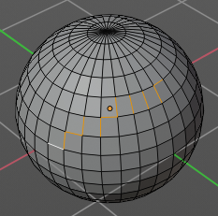
Face Stepping
Traverse connected faces.

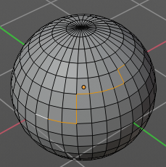
Topology Distance
Find the minimum number of steps instead of the shortest distance.

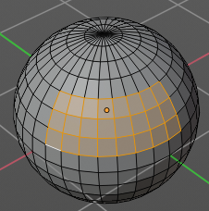
Fill Region
Select the region faces too.

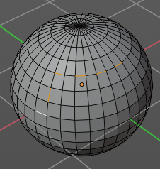
Nth Element
Don't select the whole path, but just every nth element of it.

Skip
This is connected to nth element. Number of elements to skip at once.

Offset
This is connected to nth element. Start with an offset.

Sharp Edges
Select all edges that are marked as sharp.

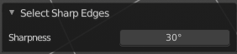
Last Operator Select Sharp Edges

Sharpness
The angle after which a sharp edge gets selected.

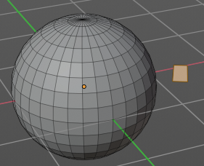
Loose Geometry
Selects loose geometry.

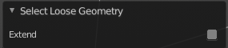
Last Operator Select Loose Geometry

Extend
Extend the current selection.

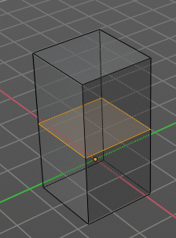
Interior Faces
Select faces where all edges have more than 2 faces. In the picture here we have inlaying faces by joining two cubes together, then merge the vertices by distance. So the two faces from the former two cubes are now interior faces. That's usually unwanted geometry that you want to select and to remove.

Faces by Sides
Selects faces that has the same number of edges, or better said vertices. Tris, quads, N-gons.

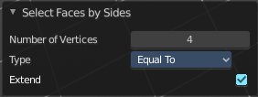
Last Operator Select Faces by Side

Sharpness
Extend the current selection.

Number of vertices
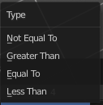
How many numbers of vertices the face should have. 4 is a quad.

Type
Selection type.

Extend
Extend the current selection.

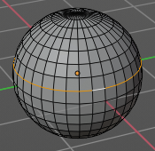
Edge Loop
Selects a loop of edges from a selected edge. The method stops at poles. That's vertices where three or more than four edges comes together. At a UV sphere the north and south pole ...

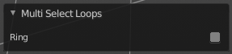
Last Operator Multi Select Loops

Ring
Select edge ring instead of edge loop.

Edge Ring
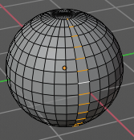
Selects edges parallel to a selected edge in the same ring of faces. The method stops at poles. That's vertices where three or more than four edges comes together. At a UV sphere the north and south pole ...

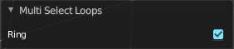
Last Operator Multi Select Loops

Ring
Select edge ring instead of edge loop.

Loop Inner-Region
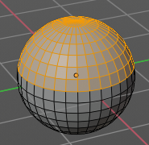
Select everything that is enclosed by an edge loop. When the loop is not closed, then it might select everything ...
By default the smaller enclosed part gets selected. The Inner-Region.

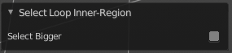
Last Operator Select Loop Inner-Region

Select Bigger
Select the bigger enclosed part instead of the smaller enclosed part.

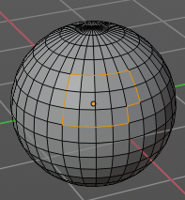
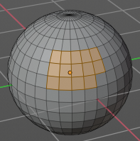
Boundary Loop
Select the edges that encloses a selection of faces.

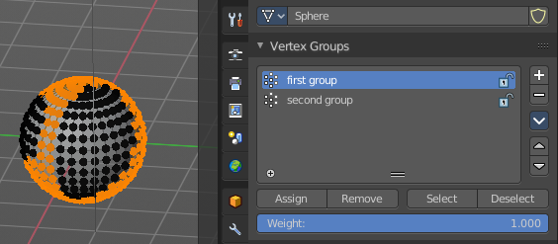
Ungrouped Verts
Selects ungrouped Vertices. Just active in vertex selection mode. And requires to have at least one vertex group assigned.

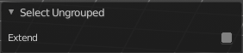
Last Operator Select Ungrouped

Extend
Extends the current selection.

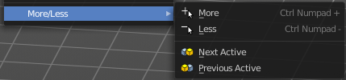
More / Less

More
Extends the current selection.

Less
Reduces the current selection.

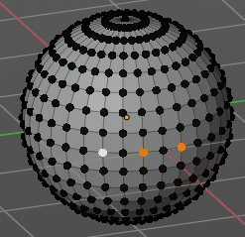
Next Active
Selects the next active element. For example, when you have two vertices selected, then the next vertice in the row with the same distance will be selected as the next active.

Previous Active
Like next active, but deselects in the other direction down to the first selected vertice with every step.

Curve Object - Edit Mode

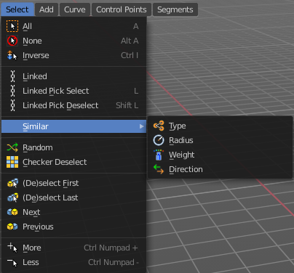

All
Select everything.

None
Select nothing.

Inverse
Invert the current selection.

Linked
Select the geometry that is directly linked with the current geometry. You can for example have a mesh with several closed submeshes. Those submeshes are not linked together, but are part of the object.

Last Operator Select Linked All

Delimit
Here you can add a limit to the selection. For example, just select up to the next seam.

Linked Pick Select
Same as with Linked. But works with what is under the mouse cursor.

Linked Pick Deselect
Same as with Linked. But works with what is under the mouse cursor. And deselects the selection.

Last Operator Select Linked

Deselect
Select or deselect.

Delimit
Here you can add a limit to the selection. For example, just select up to the next seam.

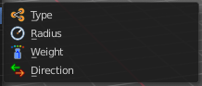
Similar
Here you can select curve geometry based on how similar certain properties are to it.

Last Operator Select Similar

Type
Here you can choose the select similar method again.

Compare
Compare with method less, greater or equal.

Threshold
Here you can adjust the threshold value after which the element counts as similar.

Random
Selects a random group of curve points.

Last Operator Select Random

Percent
How much percent will be random selected.

Random Seed
The random seed value.

Action
Select or deselect.

Checker Deselect
Deselect alternating curve points.

Last Operator Checker Deselect

Nth Element
Here you can define how much elements gets unchecked. With 2 you have a checker board pattern. Every second element gets deselected.

Skip
Skip elements before the checker algorithm deselects again.

Offset
Here you can offset the deselected elements.

De/Select First
Select or deselect first curve point.

De/Select Last
Select or deselect last curve point.

Next Active
Selects the next active element. For example, when you have two vertices selected, then the next vertice in the row with the same distance will be selected as the next active.

Previous Active
Like next active, but deselects in the other direction down to the first selected vertice with every step.

More
Extends the current selection.

Less
Reduces the current selection.

Surface Object - Edit Mode
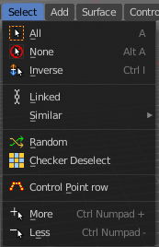

All
Select everything.

None
Select nothing.

Inverse
Invert the current selection.

Linked
Select the geometry that is directly linked with the current geometry. You can for example have a mesh with several closed submeshes. Those submeshes are not linked together, but are part of the object.

Last Operator Select Linked All

Delimit
Here you can add a limit to the selection. For example, just select up to the next seam.

Similar
Here you can select curve geometry based on how similar certain properties are to it.

Last Operator Select Similar

Type
Here you can choose the select similar method again.

Compare
Compare with method less, greater or equal.

Threshold
Here you can adjust the threshold value after which the element counts as similar.

Random
Selects a random group of control points.

Last Operator Select Random

Percent
How much percent will be random selected.

Random Seed
The random seed value.

Action
Select or deselect.

Checker Deselect
Deselect alternating control points.

Last Operator Checker Deselect

Nth Element
Here you can define how much elements gets unchecked. With 2 you have a checker board pattern. Every second element gets deselected.

Skip
Skip elements before the checker algorithm deselects again.

Offset
Here you can offset the deselected elements.

Control Point Row
Selects a row of control points, including the active one.

More
Extends the current selection.

Less
Reduces the current selection.

Metaball Object - Edit Mode

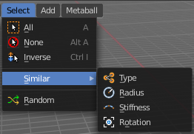

All
Select everything.

None
Select nothing.

Inverse
Invert the current selection.

Similar
Here you can select metaball geometry based on how similar certain properties are to it.

Last Operator Select Similar

Type
Here you can choose the select similar method again.

Compare
Compare with method less, greater or equal.

Threshold
Here you can adjust the threshold value after which the element counts as similar.

Random
Selects a random metaball element.

Last Operator Select Random

Percent
How much percent will be random selected.

Random Seed
The random seed value.

Action
Select or deselect.

Grease Pencil Object - Edit Mode, Sculpt Mode
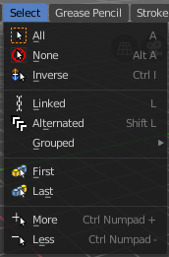

All
Select everything.

None
Select nothing.

Inverse
Invert the current selection.

Linked
Select the geometry that is directly linked with the current geometry. You can for example have a mesh with several closed submeshes. Those submeshes are not linked together, but are part of the object.

Last Operator Select Linked All

Delimit
Here you can add a limit to the selection. For example, just select up to the next seam.

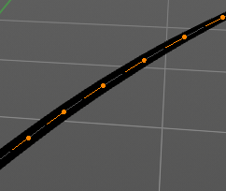
Alternated
Select every second element.

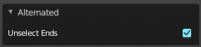
Last Operator Alternated

Unselect Ends
The end points are always unselected.

Grouped
Select grouped strokes by layer or color.

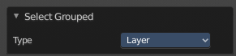
Last Operator Select Grouped

Type
Here you can again adjust if you want to select by layer or color.

First
Select the first element in the stroke.

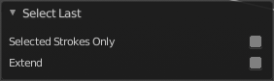
Last Operator Select First

Selected Strokes only
Only select the first point of strokes that has already some geometry selected.

Extend
Extend the current selection.

Last
Select the last element in the stroke.

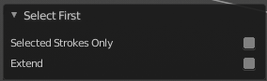
Last Operator Select Last

Selected Strokes only
Only select the last point of strokes that has already some geometry selected.

Extend
Extend the current selection.

More
Extends the current selection.

Less
Reduces the current selection.

Armature Object - Edit Mode

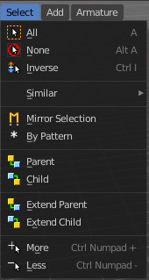

All
Select everything.

None
Select nothing.

Inverse
Invert the current selection.

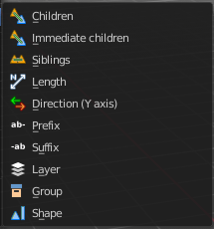
Similar
Here you can select metaball geometry based on how similar certain properties are to it.

Most methods are self explaining. Immediate children selects just the direct children of the active object, while Children selects everything downwards the hierarchy.

Last Operator Select Similar

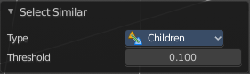
Type
Here you can choose the select similar method again.

Compare
Compare with method less, greater or equal.

Threshold
Here you can adjust the threshold value after which the element counts as similar.

Mirror Selection
Select the mirrored parts of an object. For example for L.bone it selects R.bone.

Last Operator Select Mirror

Extend
Extends existing selection instead of deselecting everything first.

By Pattern
Selects all objects whose name matches the entered string. For missing parts you need to add an asterix.
For example, you have four cubes in the scene. Cube, Cube.001, Cube.002 and mycube3. Then the term " Cube " will just select the first cube. While the term " Cube* " will select the first three. And " *cube* " will select all four.
Supported wild-cards:
* matches everything
? matches any single character
[abc] matches characters in “abc”
[!abc] match any character not in “abc”
The tool operates immediately at entering the string.

Pattern
Here you can type in your string.

Case Sensitive
When ticked then the string comparison happens by taking upper and lower letters into account.

Extend
Extends existing selection instead of deselecting everything first.

Last Operator Select Pattern
The Last Operator Select Pattern contains the same menu items than the pop-up. So see above. Also, it does not appear in the 3D view. But when you call it from the edit menu or with hotkey.

Parent
Parent requires to have a parent or child relationship. It selects the parent object of the currently selected object(s).

Child
Child requires to have a parent or child relationship. It selects the child object(s) of the currently selected object(s).

Extend Parent
Extend Parent requires to have a parent or child relationship. It selects the parent object of the currently selected object(s). But keeps the active object in the selection, even when it's not currently selected.

Extend Child
Extend Child requires to have a parent or child relationship. It selects the child object(s) of the currently selected object(s). But keeps the active object in the selection, even when it's not currently selected.

More
More requires to have a parent or child relationship. It expands the selection.

Less
Less requires to have a parent or child relationship. It reduces the selection.

Armature Object - Pose Mode

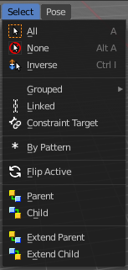

All
Select everything.

None
Select nothing.

Inverse
Invert the current selection.

Grouped
Select grouped bones by type.

Constraint Targets
Select the bones used as targets for the currently selected bone.

By Pattern
Selects all objects whose name matches the entered string. For missing parts you need to add an asterix.
For example, you have four cubes in the scene. Cube, Cube.001, Cube.002 and mycube3. Then the term " Cube " will just select the first cube. While the term " Cube* " will select the first three. And " *cube* " will select all four.
Supported wild-cards:
* matches everything
? matches any single character
[abc] matches characters in “abc”
[!abc] match any character not in “abc”
The tool operates immediately at entering the string.

Pattern
Here you can type in your string.

Case Sensitive
When ticked then the string comparison happens by taking upper and lower letters into account.

Extend
Extends existing selection instead of deselecting everything first.

Last Operator Select Pattern
The Last Operator Select Pattern contains the same menu items than the pop-up. So see above. Also, it does not appear in the 3D view. But when you call it from the edit menu or with hotkey.

Flip Active
Mirrors the bone selection. Works with a armature with mirrored parts.

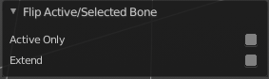
Last Operator Flip Active/Selected Bone

Active Only
Only select the mirror part of the active bone.

Extend
Extend the current selection.

Parent
Parent requires to have a parent or child relationship. It selects the parent object of the currently selected object(s).

Child
Child requires to have a parent or child relationship. It selects the child object(s) of the currently selected object(s).

Extend Parent
Extend Parent requires to have a parent or child relationship. It selects the parent object of the currently selected object(s). But keeps the active object in the selection, even when it's not currently selected.

Extend Child
Extend Child requires to have a parent or child relationship. It selects the child object(s) of the currently selected object(s). But keeps the active object in the selection, even when it's not currently selected.

Lattice Object - Edit Mode

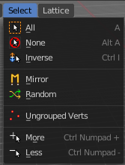
All
Select everything.

None
Select nothing.

Inverse
Invert the current selection.

Mirror
Select the mirrored parts to the current selection.

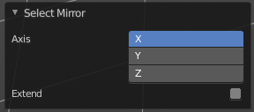
Last Operator Select Mirror

Axis
Here you can choose the world axis to mirror at.

Extend
Extends existing selection instead of deselecting everything first.

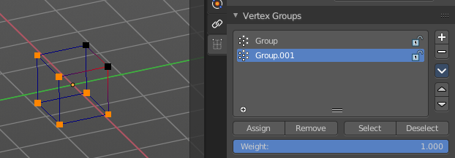
Ungrouped Verts
Selects ungrouped Vertices. Requires to have at least one vertex group assigned.

Last Operator Select Ungrouped

Extend
Extends the current selection instead of deselecting everything first.

More
Extends the current selection.

Less
Reduces the current selection.

Particles - Particle Mode
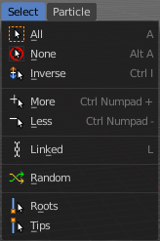

All
Select everything.

None
Select nothing.

Inverse
Invert the current selection.

More
Extends the current selection.

Less
Reduces the current selection.

Linked
Selects the linked particles.

Random
Selects random particles.

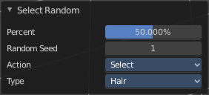
Last Operator Select Random

Percent
The Percentage of objects that should be selected randomly.

Random Seed
The Seed for the random number generator.

Action
Action is a drop-down box where you can choose if you want to select or to deselect random.

Type
Select the whole hair, or hair points.

